Supplementary materials

Supplementary table 1. Primers for quantitative polymerase chain reaction
Gene | Forward primers（5’-3’） | Reverse primers（5’-3’） | Product  (bp）
nodal | ACCATGCCTACATCCAGAGCC | CCTGCCATTGTCCACATAAAGC | 116
slug | AGAAGCCCAACTACAGCGAACT | AGCTGCCGACGATGTCCATA | 149
snail | TTGTAACAAGGAGTACCTCAGCC | AGCCAGACTCTTGGTGCTTGT | 302
e-cad | CGACCGGAAGTGACTCGAAAT | TCAGAACCACTGCCCTCGTAAT | 188
twist1 | CCCACCCCACTTTTTGACGA | CAGTGGCTGATTGGCAAGAC | 82
n-cad | CAATGGAGACTGCACGGACG | TCCCGCCGTTTCATCCATAC | 135
Candida albicans | CATCATCTCAACAAGCCGACAA | TGAGCAACGTGGATTGGGTCTA | 106
Pseudomonas aeruginosa | TCCTGGACTGCATCACCTCG | GCTTGGCGTTCGGAATCAC | 126
klebsiella pneumonia | TGGGCGGTAAAGTGCTGGTT | TCCGGTTTCGACGTTTCACA | 289
Acinetobacter baumannii | AGACGGCGTTATCGTTGCTC | CAGAAGCTAAACGAGTTGGACGA | 203
Xanthomonas maltophlia | GAAGGCATCCAGCGCAACT | GGTGTTGTTGATGCGCTTGAC | 312
Staphylococcus aureus | AAGGGGAATCAGCGGGAGA | TTGTCCGCCTTTACCACTGTG | 248
β-actin | GTGACGTTGACATCCGTAAAGA | GTAACAGTCCGCCTAGAAGCAC | 287

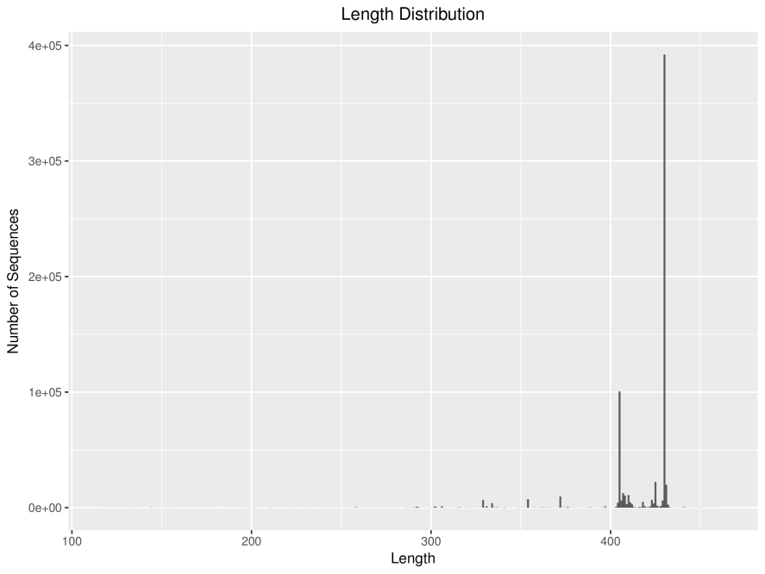
Supplementary figure 1. Distribution of sequence length. The abscissa is the length distribution of all sample sequences, and the ordinate is the total number of sequences corresponding to each length value.

Supplementary figure 2. Statistical results of OTU in each group. A-F was the number of OTU of each group at each taxonomic level. (* p < 0.05 and ** p < 0.01 vs. Control.)

